SKILL-7
- Process Synchronization and Child Process Monitoring Using waitpid().
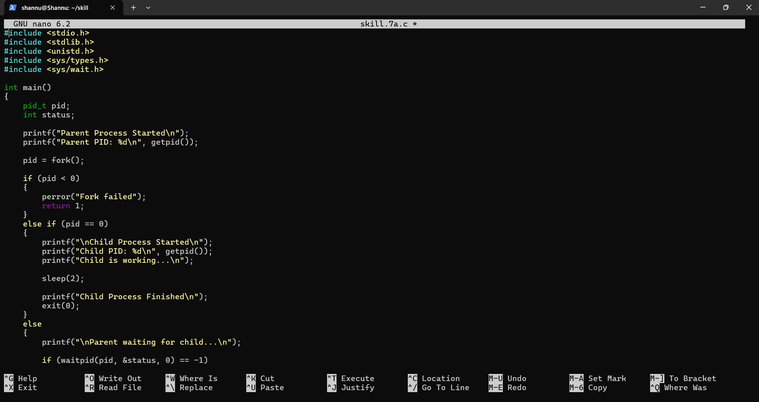
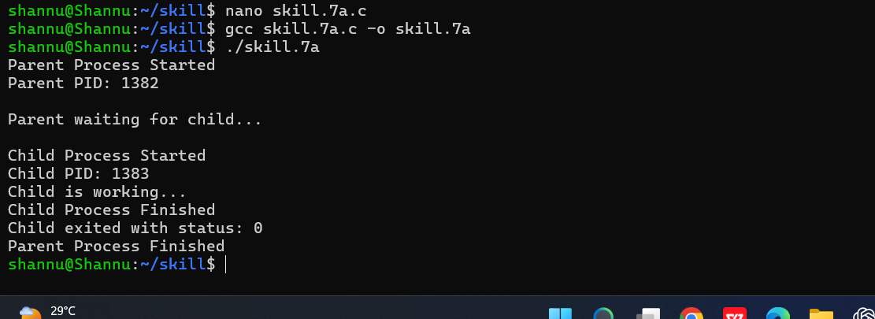
To Retrieve PATH Variable, Parse Search Directories, Locate Executables, Verify Permissions, Handle Missing Commands, Test Command Resolution.
